
ABC Solutions Pvt. Ltd.
Document Title: Corporate Overview
Version: 1.0
Effective Date: January 1, 2026
Classification: Internal Use

1. Company Overview
ABC Solutions Pvt. Ltd. is a technology and services organization committed to delivering high-quality, compliant, and scalable solutions to its clients across industries. The Company operates under a structured governance framework with clearly defined leadership, accountability, and functional ownership.

2. Vision, Mission, and Values
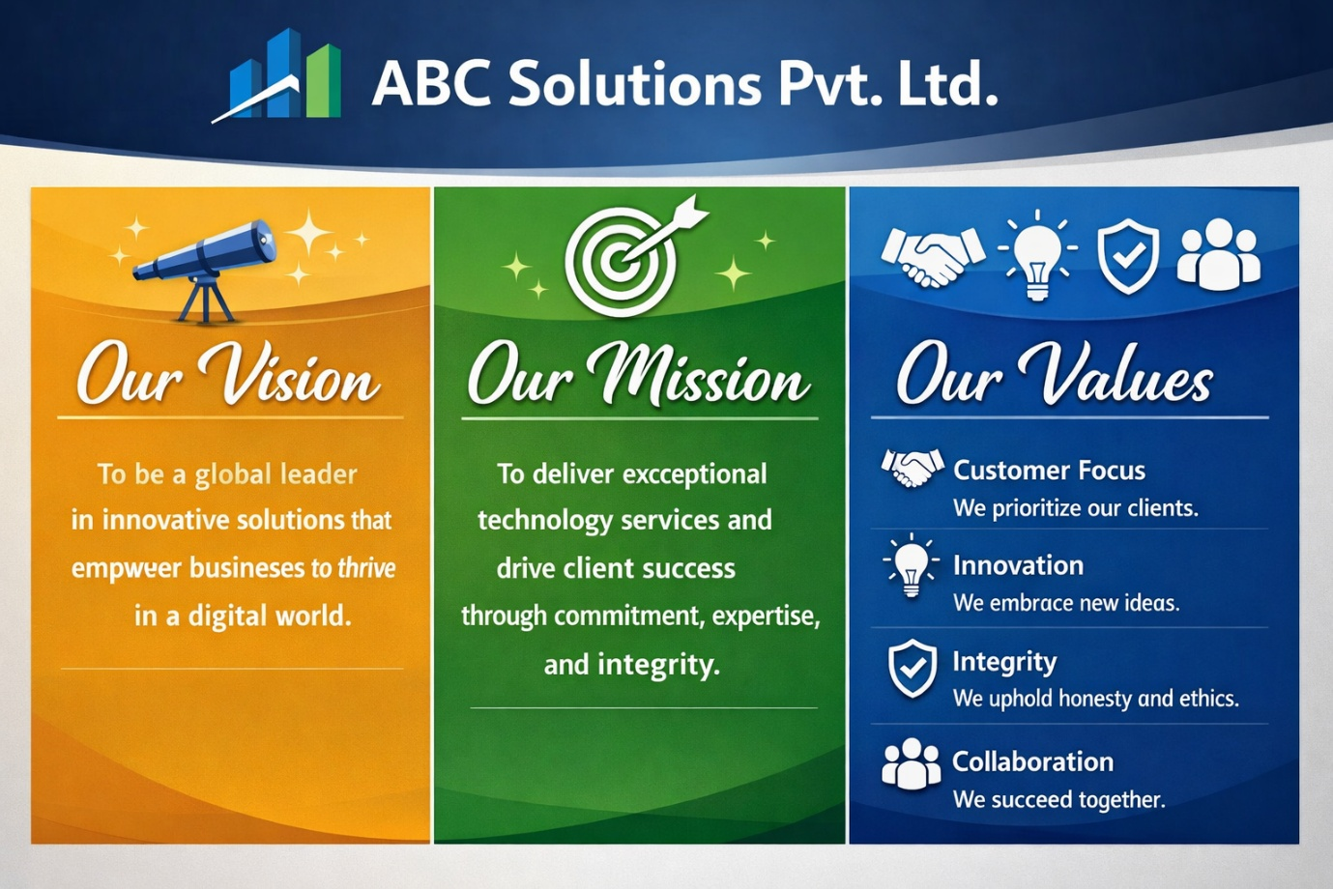

3. Organizational Structure
ABC Solutions Pvt. Ltd. follows a hierarchical organizational structure to ensure effective governance, decision-making, and operational control. The structure defines reporting relationships, functional leadership, and segregation of duties across executive management, business operations, technology, finance, human resources, and compliance.
The organization is led by the Chief Executive Officer (CEO) and supported by the executive leadership team, including the Chief Operating Officer (COO), Chief Financial Officer (CFO), Chief Technology Officer (CTO), Chief Marketing Officer (CMO), Chief Human Resources Officer (CHRO), Chief Information Security Officer (CISO), and Company Secretary. Each function operates with clearly defined roles and accountability in alignment with statutory, regulatory, and internal control requirements.
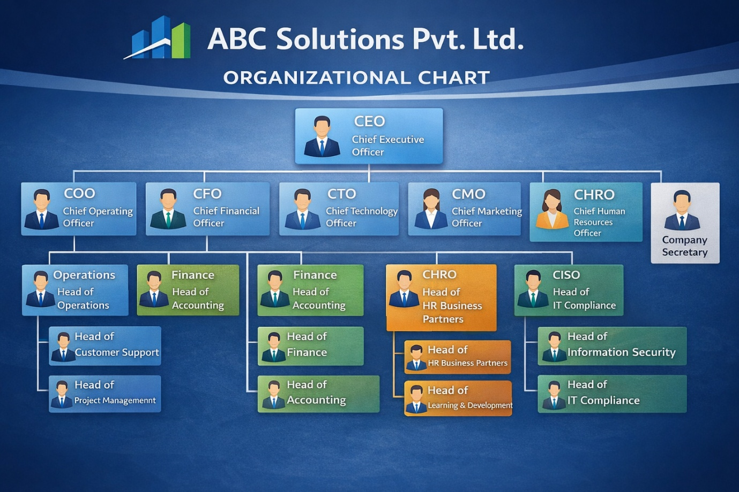

4. Governance and Accountability
The organizational structure and value framework together ensure:
- Clear reporting lines and escalation paths
- Segregation of operational, financial, and compliance responsibilities
- Alignment between leadership decisions and corporate values
- Support for statutory compliance, audit readiness, and risk management
- Transparent performance management and people development processes

5. Document Control
This document shall be maintained by the Human Resources Department and reviewed annually or upon significant organizational restructuring. All employees shall have access to the latest approved version through the Company intranet or document management system.

Confidential – For Internal Use Only – ABC Solutions Pvt. Ltd.

